CAPSTONE PROJECT

Project Name: Airbnb Booking Analysis

Project Type: Exploratory Data Analysis (EDA)

Contribution: Individual
Name: Jaya

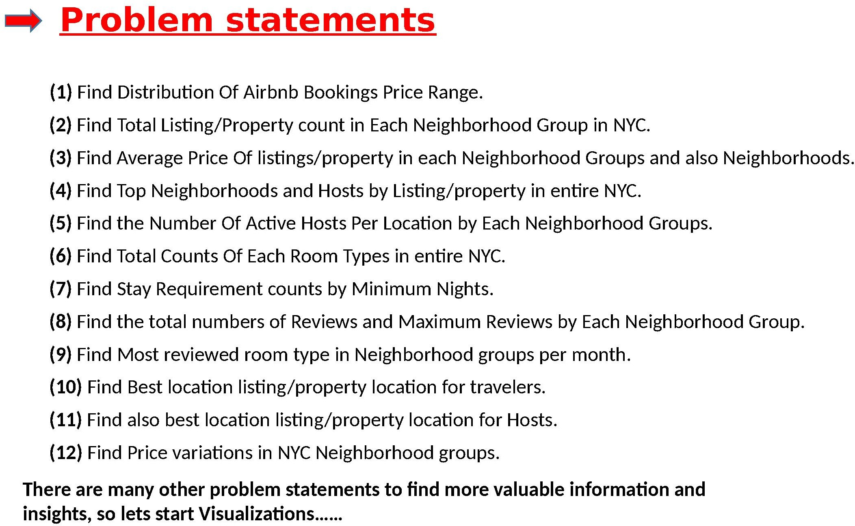

📦 Capstone Project: Exploratory Data Analysis on E-Commerce Data

🧠 Objective:
The goal of this project is to perform Data Cleaning and Exploratory Data Analysis (EDA) on a real-world E-Commerce dataset to uncover meaningful patterns, customer behaviors, and country-wise trends.

📁 Dataset Overview
- Source: Kaggle - E-Commerce Data
- Company: UK-based non-store online retail
- Product Type: All-occasion gifts
- Customer Base: Mostly wholesalers (local and international)
- Time Period: 1st December 2010 – 9th December 2011

🔧 Part 1: Data Cleaning

🎯 Objectives:
- Identify and clean missing or incorrect values.
- Engineer useful features for analysis.

✅ Tasks:
- Check for Missing Values:
  - Count missing values in each column.
  - Display percentage of missing data.
- Remove Missing or Invalid Data:
  - Drop rows with missing values.
  - Remove rows where Quantity is negative (indicating cancellations or returns).
- Create New Columns:
  - amount_spent = Quantity × UnitPrice
  - Extract:
    - Month from InvoiceDate
    - Day from InvoiceDate
    - Hour from InvoiceDate
- Data Type Conversions:
  - Ensure InvoiceDate is in datetime format.
  - Convert categorical fields like Country, InvoiceNo to str type if needed.

📊 Part 2: Exploratory Data Analysis (EDA)

🎯 Objectives:
- Discover patterns across time, customers, and countries.
- Identify peak order times and revenue contributors.

✅ Key Questions & Visualizations:
- 📌 Orders Per Customer:
  - How many orders did each customer make?
  - Display the TOP 5 customers with the most orders.
- 📅 Monthly Orders:
  - Count orders per month.
  - Plot time-series to find sales trends.
- 📆 Daily Orders:
  - Analyze how orders vary by day of the week.
- ⏰ Hourly Orders:
  - At what time do customers place the most orders?
  - Create a bar chart of number of orders per hour.
- 💵 Unit Price Distribution:
  - Explore the distribution of product prices.
  - Detect any outliers or spikes.
- 🌍 Country-wise Analysis:
  - Which countries place the most orders?
  - Plot the TOP 5 countries by:
    - Number of orders
    - Total amount spent
- 📈 Trend Analysis:
  - What month had the highest sales?
  - Was there a drop/increase around holidays?
  - Explore patterns around weekdays vs weekends.

🧾 Summary & Insights
Write a short summary of your findings. Use the following questions to reflect:
- Which country generated the most revenue?
- When does the company receive the most orders (days, hours)?
- Are there any anomalies (e.g., high-value free items, cancellations)?
- How does customer behavior vary over time?

